Building WorkflowMaker

For WorkflowMaker version 1.1.1 and later
Windows 10 & 11, Ubuntu-based Linux distributions
64-bit only

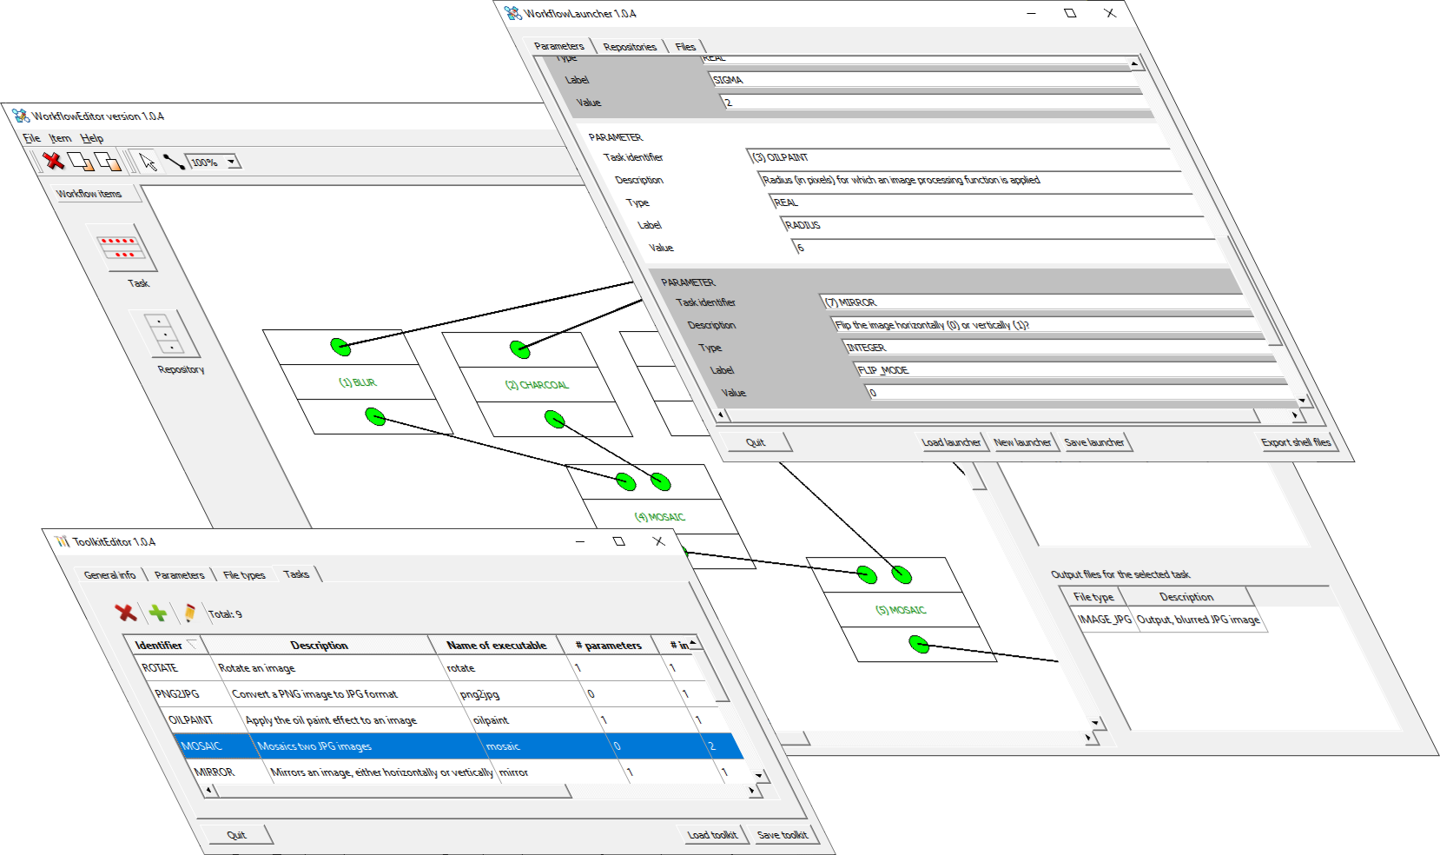



Table of contents
1 The goal 4
2 The tools 4
3 The organization of the source code 5
3.1 The installer sub-folder 5
3.2 The libraries sub-folder 6
3.3 The samples sub-folder 7
3.4 The tools sub-folder 8
4 Building WorkFlowMaker 9
4.1 Building for the Linux platform 9
4.1.1 Target platforms 9
4.1.2 Are all the required tools available? 9
4.1.3 Automated building 11
4.1.4 Building by hand 12
4.1.5 The deb folder structure 12
4.1.6 Before building the deb package: finding dependencies 13
4.1.7 Purge the deb folder 16
4.1.8 Creating the deb package 16
4.2 Building for Windows platforms 18
4.2.1 The tools 18
4.2.2 Preparing the Qt and MSVC redistributables 19
4.2.3 The structure of the windows installer folder 20
4.2.4 Automated building 21
4.2.5 Building by hand 22
4.2.6 Building the installer (when building manually) 23
4.3 The API documentation 24
5 Open Source licenses 26
5.1 The rapidxml library 26
5.2 The Qt 6 framework 26
5.3 Images 27
5.4 WorkflowMaker 27
List of figures
Figure 1: The organization of the source code. 5
Figure 2: The structure of the installer sub-folder. 6
Figure 3: The structure of the libraries sub-folder. 6
Figure 4: The structure of the samples sub-folder. 7
Figure 5: The structure of the tools sub-folder. 8
Figure 6: Selecting the right Qt libraries for Qt creator. The path to qmake is shown. 10
Figure 7: Setting the path to the qmake tool. 11
Figure 8: The structure of the .deb folder as created by the build process. 14
Figure 9: Modifying the control file to find dependencies. 14
Figure 10: The output of find_dependencies.sh. 15
Figure 11: Updating the DEBIAN/control file with the new dependencies. 16
Figure 12: The purged deb package folder. 17
Figure 13: Installing Qt 6 on Windows - Component selection. 18
Figure 14: The structure of the source code, extended for Windows builds. 19
Figure 15: The structure of the QT redistributable folder. 19
Figure 16: The structure of the Windows (installer) deployment folder. 21
Figure 17: Building the windows installer using HM NIS Edit. 24
Figure 18: The doc_html folder for the ToolkitEditor tool including its API documentation. 25
Figure 19: An example of the API documentation in HTML format. 26

The goal
This document explains the organization of the WorkflowMaker software, describing its distribution across different folders and sub-folders, and indicating what can be found in each one. Additionally, it provides instructions for building WorkflowMaker from the source code, for both Windows and Linux. It specifies the tools to be used; in the case of Linux, it also indicates the procedure for installing said tools. Finally, some important comments are made regarding Application Programming Interface (API) documentation.


Due to the limited resources available, the build instructions for Linux systems provided in the next sections are guaranteed to work only on Debian-based Linux operating systems. Furthermore, and since version 6 of the Qt framework (see section 2) is required, only relatively new distributions such as Ubuntu 24.10 or Linux Mint 22 are supported; previous ones include version 5 of said framework only.

The tools
To build WorkFlowMaker from source the following tools are required:

- Windows
  - MSVC 2022 Community Edition (https://visualstudio.microsoft.com/downloads/).
  - Qt version 6 (https://www.qt.io/download-open-source). Download the prebuilt binaries for the MSVC 2022 compiler (msvc19_64).
  - The NSIS (Nullsoft Scriptable Install System (https://nsis.sourceforge.io/Download).
  - The HM NIS EDIT editor (https://hmne.sourceforge.net/). This editor is used to build the Windows installer together with NSIS.
  - doxygen (https://www.doxygen.nl/download.html) and graphviz (https://graphviz.org/) to build the documentation.
- Linux
  - gcc 13.
  - The dpkg and dpkg-dev packages (for building .deb packages and finding package dependencies).
  - Qt version 6.
  - doxygen and graphviz, to build the documentation.

For Linux, all tools should be available using the built-in package manager.

On Linux do not download version 6 of the Qt libraries from Qt’s website; use the ones available in the system repositories instead. Deploying a Linux application relying on the libraries included in the official Qt’s distribution is much more complicated than using the system libraries; furthermore, the size of the resulting deb package is notably bigger. See section 4.1.2 for details about installing the necessary tools on Linux.

The organization of the source code
The first-level sub-folders of WorkflowMaker’s main folder is organized as depicted in Figure 1. Their contents is described below;

- data – XML schema files defining the syntax of the toolkit, workflow and launcher files.
- docs – The documentation, including this guide.
- installer – Scripts to build installers, either for Windows or Linux platforms.
- libraries – The source code of the libraries developed and used by the tools in WorkflowMaker.
- samples – Data and source code samples for an example toolkit (simple image processing).
- tools – The source code for the tools (ToolkitEditor, WorkflowEditor, ẄorkflowLauncher).

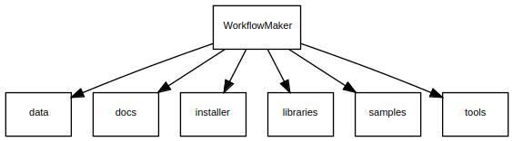Figure 1: The organization of the source code.

The installer sub-folder
The structure of the installer sub-folder is shown in Figure 2.

Two different sub-folders exist here.

The first one, installer_sw_windows includes all the necessary software and data to build a Windows installer using the Nullsoft Scriptable Install System (NSIS). This includes the NSIS script - the code defining how to build the installer - as well as several images and icons required to build it.

The second sub-folder, installer_sw_linux, is targeted at building a package for Debian-based Linux platforms. There, there are three files, namely control, postinst and prerm that will be be copied to the Linux .deb package folder structure, more precisely to the DEBIAN sub-folder. These define the characteristics of the package (control), the post-build actions to start when the package is copied to the system (postinst) and those to execute when uninstalling it (prerm). See also section 4.1.
Figur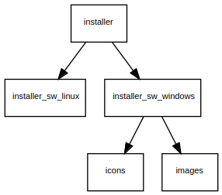e 2: The structure of the installer sub-folder.

The libraries sub-folder
Figure 3 depicts the structure of the libraries sub-folder.

Figure 3: The structure of the libraries sub-folder.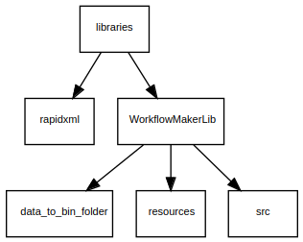

This sub-folder must contain all the libraries used by the tools in the WorkflowMaker package, either self-developed or third-party. Currently, there are two libraries, namely rapidxml (open source, https://rapidxml.sourceforge.net/) and WorkflowMakerLib, which has been developed specifically for this project.

No description is provided for the rapidxml library. Being a header-only library, it is sufficient to include those headers in the software that uses said library.

The WorkflowMakerLib folder is organized as follows;

- data_to_bin_folder – A single file is included here, namely workflowmaker_version.txt. It contains the version string for all the applications in WorkflowMaker. Changing this file and rebuilding the library will make all these tools to show a new version string.
- resources – Images and HTML files to help build the developer’s documentation.
- src – The source code for the library.

The samples sub-folder
An example of a WorkflowMaker toolkit (as well as workflows and launchers relying on it) has been included. It is a very simple image processing toolkits. The interest of this sample is twofold: first, it makes possible to test the tools in WorkflowMaker without the hurdle of having to define a toolkit from scratch; but, also, they show the architecture of WorkflowMaker-compliant applications. For instance, its tools read the values of their keyboard parameters and input and output file names using an options file, which is implemented using a C++ library named simple_options_file_parser included with the samples. The structure of the samples sub-folder is shown in Figure 4.

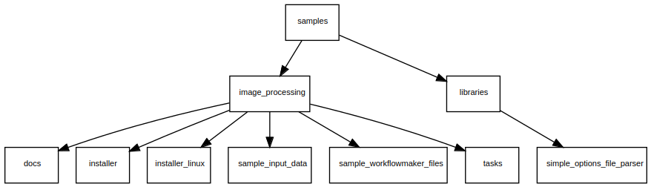Figure 4: The structure of the samples sub-folder.

The library simple_options_file_parser is organized in the same way than WorkflowMakerLib. Please refer to the description of that library to understand how the sub-folders of simple_options_file_parser are structured (in this case, however, there is no data_to_bin_folder sub-folder).

The sample image processing toolkit is organized as follows:

- docs – The user guides for the toolkit.
- sample_input_data – Files that may be used as inputs when running the tools in the toolkit (such as images).
- sample_workflowmaker_files – Example files defining one toolkit, and at least one workflow and launcher relying on the said example toolkit.
- tasks- The source code for each of the tools included in the toolkit. These are organized exactly in the same way that the WorkflowMaker tools (ToolkitEditor, WorkflowEditor, WorkflowLauncher) so refer to section 3.4 for details on their structure.

Folders installer and installer_linux are used to build installers for these samples. Please, refer to the samples documentation for more information about building said samples.

The tools sub-folder
The three tools making WorkflowMaker reside in the tools sub-folder. Figure 5 depicts its structure.

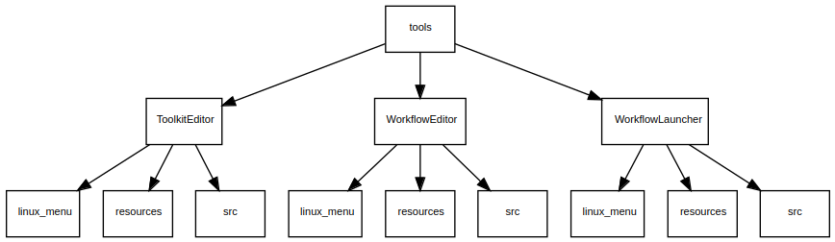Figure 5: The structure of the tools sub-folder.

All tools have been organized in the same way:

- linux_menu – Files to build a menu entry for the tool in those Linux distributions that have a system menu.
- resources – Images or other files required to build the application or the documentation.
- src – The source code.

In the main folder (such as ToolKitEditor) several files are always present:

- xxxx.pro - This is the Qt project file, used to define the components making the application and giving instructions about how to build it.
- xxxx_resources.qrc – Definition of the images used by the application. This is a Qt file too.
- postbuild.bat & postbuild.sh – Shell files for Windows and Linux respectively, stating the steps to execute once the application has been successfully built. These files take care of creating the installer’s appropriate sub-folders, copy files there (such as executable or default option files, etc). These constitute the keystone of the build system, since they prepare everything that is needed to build, later, an installer or .deb package for WorkflowMaker.
- xxxx.dox – Doxygen documentation file for the tool.

In the bullets above, xxxx stands for the name of each of the tools. For instance, the contents of the ToolkitEditor main folder is: ToolkitEditor.pro, ToolkitEditor_resources.qrc, ToolkitEditor.dox, postbuild.bat and postbuild.sh.

Building WorkFlowMaker
Building WorkflowMaker means first build the base library (WorkflowMakerLib) and then the tools (ToolkitEditor, WorkflowEditor, WorkflowLauncher).

Scripts to automate the whole build process for both for the Linux and the Windows platforms have been provided. In all cases, the result of the build process is copied to some directory(ies) so creating an installer or a deb package for WorkflowMaker is simplified, or, as it happens with Windows build, completely automated.

The following sections will discuss how to build WorkflowMaker for Linux and Windows.

In these sections, and to simplify the explanations, the WorkflowMaker folder will be referred to as workflowmaker. Hence, sub-folders like data or libraries will be written as workflowmaker/data or workflowmaker/libraries.

Building for the Linux platform

Target platforms
As already stated, due to the limited resources available, the build instructions provided in the next sections are guaranteed to work only on modern Debian-based Linux operating systems (such as Ubuntu 24.10 or Linux 22) since version 6 of the Qt framework must be available in the software repositories of these operating systems (not downloaded from the Qt website).

Are all the required tools available?
WorkflowMaker relies on the Qt framework, more precisely, on Qt version 6. Redistributing applications relying on this framework may be difficult when working on Linux platforms.

As stated above, this guide assumes that Qt6 may be built and installed on the target computer by means of the system’s repositories; this applies to both the regular and development Qt6 packages.

Relying on system packages makes easier the deployment of WorkflowMaker just by stating its dependencies in the deb package. If not present when it is installed, the operating system will download and install, automatically, the missing Qt6 libraries.

The list of tools required to develop (and thus build) WorkflowMaker on Debian-based Linux computers are listed in section 2. Below, there is a list of the commands to type on a command prompt to install the complete set of tools:

- Update the list of packages:
  - sudo apt update
- The dpkg and dpkg-dev packages, to be able to build .deb packages and find their dependencies.
  - sudo apt install dpkg
  - sudo apt install dpkg-dev
- gcc / g++
  - sudo apt install build-essential
- qt6
  - sudo apt install qt6-base-dev qt6-tools-dev qt6-tools-dev-tools
- Qt creator (the Qt IDE, Integrated Development Environment)
  - sudo apt install qtcreator
- doxygen
  - sudo apt install doxygen
- graphviz
  - sudo apt install graphviz

It is worth to highlight that Qt 6 is made of many more libraries than those installed by the command under bullet point “qt6” above. However, these are enough to develop and build WorkflowMaker.

Note that the version of Qt creator installed as shown above be a little bit outdated, which is not a problem to develop / build WorkflowMaker. If a more recent version is preferred, then it may be obtained directly from Qt’s website.

With regard to manual building (see section 4.1.4) and regardless the version of Qt Creator installed, it is necessary to configure it by selecting the “kit” installed in bullet point “qt6”. That is, the qt libraries used by this IDE must be provided by the system repositories, not downloaded from the Qt website. Figure 6 depicts Qt Creator’s Preferences/Kits windows. There, highlighted in red, it may be seen how the “system” Qt libraries have been selected. The path to the qmake tool is also highlighted, which will be needed to adapt the automated build scripts when building WorkflowMaker (see section 4.1.3).

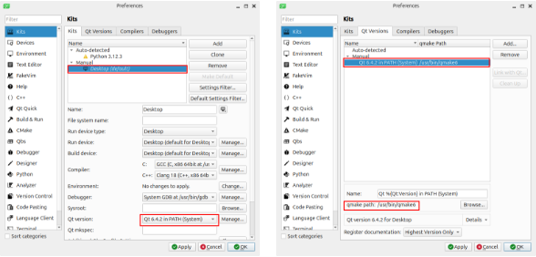Figure 6: Selecting the right Qt libraries for Qt creator. The path to qmake is shown.

Automated building
The following are the step-by-step instructions to build WorkflowMaker using the automated script.

First of all, take care of changing the version string of the software, but only if changes have made; this is not necessary when building the code just downloaded from the repository. Version changes must be reported in the following files:

- workflowmaker/libraries/WorkflowMakerLib/data_to_bin_folder/workflowmaker_version.txt – The typical version string follows the pattern x.y.z (e.g., 1.0.8). Change this value if necessary and save the file.
- workflowmaker/installer/installer_sw_linux/control – Change the line “Version: x.y-z” to match the actual version. Note the dot-dash pattern between x and y and then between y and z.

Open a terminal. Change the default directory to workflowmaker

cd workflowmaker

Check that the build script (file build_all.sh in this folder) points to the right qmake tool. To ascertain what is the path to qmake, open Qt Creator, Then go to Edit→Preferences, and select the Kits tab in the vertical tab list, and then Qt Versions in the horizontal. There (see the lower right part of Figure 6) the path to qmake is shown highlighted in red. Figure 7 below shows the first lines of build_all.sh; the line to check and eventually change has been highlighted.

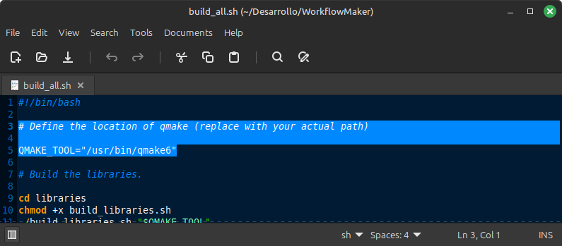Figure 7: Setting the path to the qmake tool.

The line QMAKE_TOOL=”/usr/bin/qmake6” states the path to the qmake tool. Note that this value (/usr/bin/qmake6) is obtained from the path shown in Figure 6.

If the value of the line above does not match the one shown in Figure 6, change it accordingly and save the build_all.sh file. If these values are the same, just close the file.
Make sure that the file build_all.sh has the execution privilege:

chmod +x build_all.sh

Run the build script:

./build_all.sh

The result of the execution of the script is that a new folder structure has been created and populated with all the necessary files to build the deb package (see section 4.1.5). Moreover, another folder, named workflowmaker_x.y-zz_doc_and_samples is created. It is stored in workflowmaker/installer/installer_sw_linux and contains the documentation (user guides) as well as some sample files for the image processing sample toolkit. Its structure is so simple that it is not necessary describe it here.

Building by hand
Alternatively, it is possible to build WorkflowMaker by hand, building, one by one, the several projects if is composed of. However, when building WorkflowMaker by the first time (that is, when it is downloaded from the repository) the automated build process is recommended. Later on,
when changes are made to specific components of WorkflowMaker (such as a single tool, or the library), building by hand makes much more sense.

The general process to build a single library or a tool is as follows:

- Open Qt Creator.
- Select the .pro file for the desired target (the library or any of the tools).
- Configure the project (selecting the Qt 6 installed in your computer and the target output).
- Build.

Building manually any of the components, either library or tools, will also copy the corresponding files to the deb folder structure (see section 4.1.5) as it is done by the automated process.

It is worth noting that changing the library implies rebuilding all the tools to guarantee that these changes are conveniently propagated. In general, when building manually, libraries must be built first, then the tools.

The deb folder structure
The WorkflowMaker build script creates a folder structure holding the necessary files to, later, create a deb package. This folder is always named workflowmaker_x.y-zz_amd64 and it is placed in the sub-folder workflowmaker/installer/installer_sw_linux, that is, its full path is

workflowmaker/installer/installer_sw_linux/workflowmaker_x.y-zz_amd64
Each element built (the library, each tool) copies one or more elements to this folder structure. When everything is built, the deb package may be created (see sections 4.1.6 to 4.1.8). Figure 8 on page 14 depicts the structure of the said folder as created by the build process. The contents of each sub-folder is described below.

- Root folder (that is, workflowmaker_x.y-zz_amd64 itself). A file named find_dependencies.sh is copied here. It may be used to ascertain what are the dependencies (in terms of system libraries) on which the tools in WorkflowMaker rely. When said dependencies are already known, this file must be deleted.
- DEBIAN – It contains the control, postinst and prerm files.
  - control – Defines the contents of the package, according to the syntax required for this files. It includes the name of the package, its version, the packages on which it depends, for instance. If the software is changed, this file must be modified in order to reflect any changes (such as, of course, the version number or dependencies).
  - postinst – This is a shell file that is executed as the last step when the deb package is installed. In the case of WorkflowMaker, it takes care of creating the menu entries for the different tools.
  - prerm – It is executed as the first step when the deb package is uninstalled. In this case it takes care of removing the menu entries for the applications.
  - All these files are copied from workflowmaker/installer/installer_sw_linux.
- debian – This folder contains an extra copy of the control file (see DEBIAN sub-folder above) since, when finding dependencies, the existence of this sub-folder (debian) as well as said control file are required. Note that this sub-folder must be deleted once the dependencies have been ascertained, prior to building the deb package. This is why it is highlighted in red in Figure 8.
- usr/local/bin – Here, the executable files for the tools as well as the XML schema definitions for toolkits, workflows and launchers are copied. The file with the package version string is also stored here. The executable files are produced by building the respective tools; the XML schema definitions are copied from workflowmaker/data. The version string file is copied from workflowmaker/libraries/WorkflowMakerLib/data_to_bin_folder.
- usr/share/workflowmaker – Here, the .desktop and icons for the tools are stored. These are copied, for each tool, from their linux_menu subfolders; for instance, the files for ToolkitEditor are copied from workflowmaker/tools/ToolkitEditor/linux_menu.

Before building the deb package: finding dependencies
This step may be skipped most of the times since dependencies do not change so often. In fact, it may be ignored when building WorkflowMaker just after downloading it from the repository.

Finding the dependencies of WorkflowMaker is something that must be done every now and then, since the contents of the system’s (operating system) repositories may vary, including newer versions of some libraries needed by the tools.
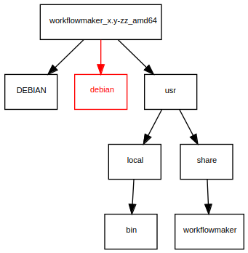Figure 8: The structure of the .deb folder as created by the build process.

The control file stored in the debian and DEBIAN directories (see Figure 8) contain the dependencies at the moment of writing this guide. If you think that it is convenient to ascertain if these dependencies have changed, proceed as follows:

- Edit the control file in the debian (not DEBIAN) folder.
- Add an extra line, just under “Package: workflowmaker” saying “Source: workflowmaker”. See the highlighted lines in Figure 9. Ignore, by now, the “Dependencies:” field in this file, since it states the old dependencies for WorkflowMaker.
- Save the file.

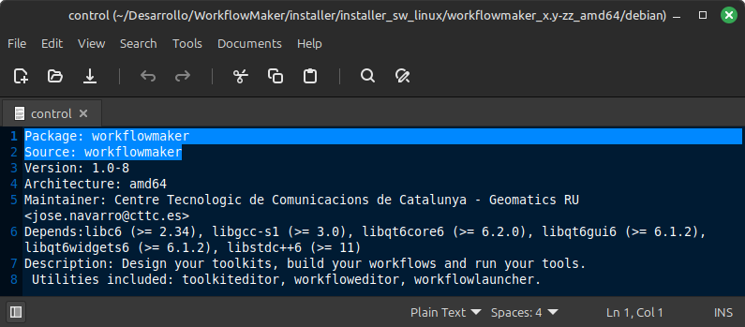Figure 9: Modifying the control file to find dependencies.

Then,

- Open a command prompt.
- Change the default directory to workflowmaker_x.y-zz_amd64.
- Type the following command: ./find_dependencies.sh.

The command above produces an output file, named dependencies.txt. There, the dependencies for all the tools in WorkflowMaker are listed. See Figure 10. There, a line is included for each tool. Note that different versions of a system library may be required: as seen in said figure, versions 6.1.2 and 6.4.0 are required by different tools. In these cases, the highest version must be used.

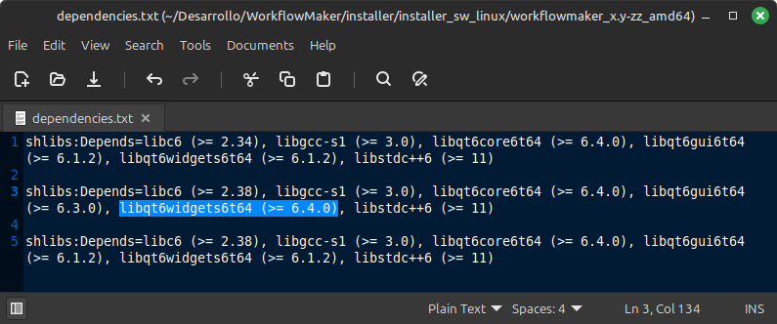Figure 10: The output of find_dependencies.sh.

The idea is to obtain the unique list of dependencies (keeping the highest versions) written in the format required by the control file. In the case of the example above, this line would be:

Depends:libc6 (>= 2.38), libgcc-s1 (>= 3.0), libqt6core6 (>= 6.4.0), libqt6gui6 (>= 6.3.0), libqt6widgets6 (>= 6.4.0), libstdc++6 (>= 11)

Note the use of the highest version required for each library in the dependencies set.

Then, delete the file dependencies.txt created by find_dependencies.sh in the debian folder since it is no longer needed.

The next step is to edit the control file located in the DEBIAN (not debian) folder and replace the line with the dependencies with the ones just found. Figure 11 depicts this change (see the highlighted line).

Finally, save the control file.

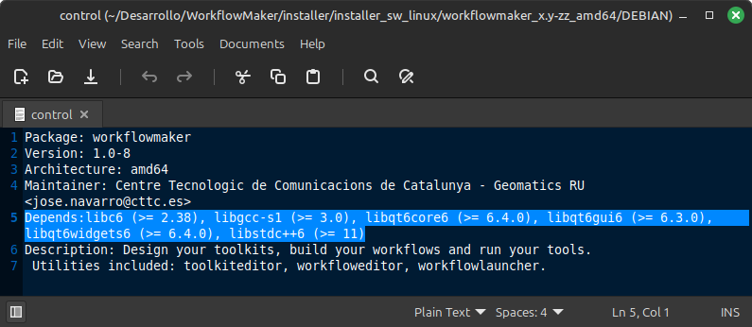Figure 11: Updating the DEBIAN/control file with the new dependencies.

Purge the deb folder
As stated in section 4.1.5 the build process (either automated or manual) creates the folder named workflowmaker_x.y-zz_amd64 where the several files making the deb package are stored. This folder included several sub-folders, among which one named debian (not DEBIAN) could be found. Figure 8 shows in red said folder. The purpose of this debian folder was to make possible finding the dependencies of the tools in WorkflowMaker (section 4.1.6).

At this point of the process, the debian folder must be deleted, since it may not be part of the deb folder structure when the deb package is built. Therefore, it must be removed. Figure 12 shows the structure of workflowmaker_x.y-zz_amd64 after this removal takes place. Compare it with Figure 8.

Now, it is possible to build the deb package.

Creating the deb package
Once that the library and the tools have been built, either automatically or manually, and the deb package folder purged, it is possible to create a deb package. To do it, follow the steps below.

Rename the folder workflowmaker_x.y-zz_amd64 located in workflowmaker/installer and name it according to the version it implements. For instance, if the new version is 1.0.8, then the new name should be workflowmaker_1.0-8_amd64.

Open a terminal. Change the default directory to workflowmaker/installer/installer_sw_linux

cd workflowmaker/installer/installer_sw_linux
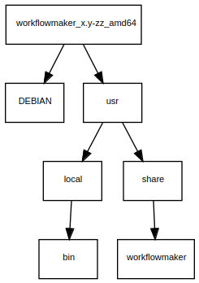Figure 12: The purged deb package folder.

Run the following command:

dpkg-deb --build --root-owner-group <deb-folder>

where <deb-folder> stands for the deb folder just renamed. For instance, if the original workflowmaker_x.y-zz_folder has been renamed to workflowmaker_1.0-8_amd64, then the command should be:

dpkg-deb --build –root-owner-group workflowmaker_1.0-8_amd64

Obviously, the name of the <deb-folder> must be changed in the example above to match the actual name of the deb folder.

This will create the deb file, which may be used to install WorkflowMaker in Debian-based Linux distributions. It is created in the workflowmaker/installer/installer_sw_linux folder.

The name of the deb package will be workflowmaker_x.y-z_amd64.deb, where x.y-z stands for the actual version built. If it is, for instance, 1.0-8, then the name of the package will be workflowmaker_1.0-8_amd64.deb.

Building for Windows platforms

The tools
The tools required to develop / build WorkflowMaker are listed in section 2. Installing these is straightforward thanks to the GUI-based installers provided.

It is worth to highlight, however, that Qt 6 must be installed using the official Windows x64 online installer available at the Qt website (https://www.qt.io/download-open-source). When installing, take care of including the “Developer and Designer Tools” as well as the Qt 6 libraries (see Figure 13).

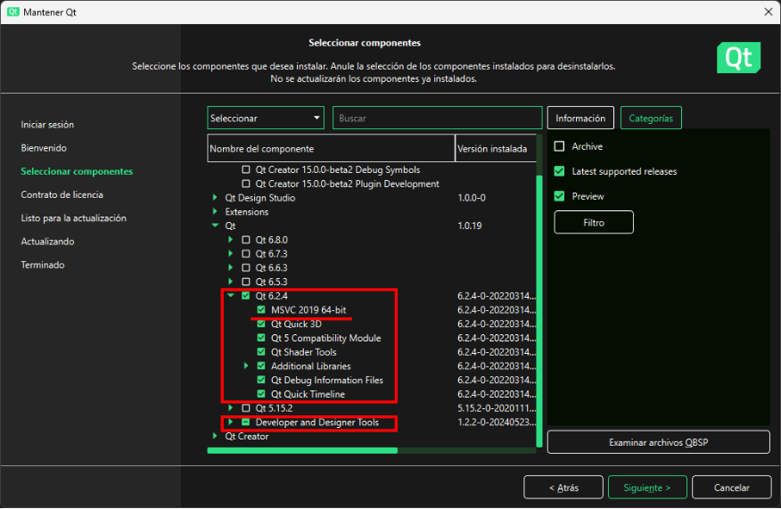Figure 13: Installing Qt 6 on Windows - Component selection.

The version selected in the figure above was the one closest to that available on Linux at the moment of writing this guide. Later versions (such as 6.8.0, at the top of the bigger red rectangle) may be selected. However, versions greater than 6.2.4 (the one selected) have not been tested (although no problems should be expected).

Note that the libraries for the MSVC compiler (underlined in the figure) have been included. These are the equivalents of the Linux qt system libraries (see section 4.1.2).

Preparing the Qt and MSVC redistributables
Once that the tools have been installed, the first thing to do to build WorkflowMaker from source on Windows platforms is modifying the folder structure shown in Figure 1 to include two more sub-folders, namely QT_redistributables and VC_redistributables. These folders must be added manually, since they are not part of the source code distribution. Figure 14 depicts this new folder structure. The red boxes stand for the changes.

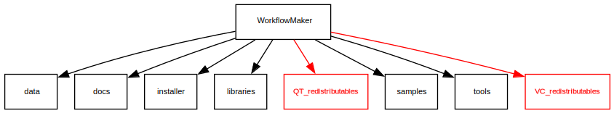Figure 14: The structure of the source code, extended for Windows builds.

The QT_redistributables folder must be structured as shown in Figure 15. The VC_redistributables folder must have no sub-folders.

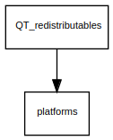Figure 15: The structure of the QT redistributable folder.

The QT_redistributables folder must contain all the Qt dynamic link libraries (DLLs) and platform code required by the applications. These are:

- Root:
  - Qt6Core.dll
  - Qt6Gui.dll
  - Qt6Widgets.dll

- Sub-folder platform
  - qwindows.dll

All these dynamic libraries must be copied from the Qt installation folder. On Windows, this is typically C:\Qt. Assuming that this is the root directory, then all the DLLs that must be copied to the Qt’s redistributables root folder may be found at

C:\Qt\<qt_version>\<compiler_version>\bin
while qwindows.dll, which is copied to the platforms sub-folder must be obtained from

C:\Qt\<qt_version>\<compiler_version>\plugins\platforms

In these two paths, <qt_version> stands for the specific version of Qt installed (such as 6.2.4) and <compiler_version> for the version of the compiler for which the pre-built Qt binaries have been installed, such as msvc19_64.

The VC_redistributables folder must contain the official Microsoft installer for the redistributables for the compiler used to build WorkflowMaker. The URL to download these may change with time, but at the time of writing this guide it could be downloaded from:

https://learn.microsoft.com/en-us/cpp/windows/latest-supported-vc-redist?view=msvc-170#visual-studio-2015-2017-2019-and-2022

The file to download is that for x64 architectures; again, at the time of writing this guide its name is VC_redist.x64.exe. This file must be copied in the VC_redistributables folder.

These redistributables (either Qt or VC) will be copied to the deployment directory (see next section) so the installer will incorporate these to the setup program that will be, finally, created.

The structure of the windows installer folder
When building WorkflowMaker for Windows, the build scripts create automatically a folder where all the files required to make an installer will be copied. This folder, named deployment, is created inside the Windows installer sub-directory, that is, at

workflowmaker/installer/installer_sw_windows/deployment

Figure 16 depicts the structure of said deployment folder. These are the contents copied there by the build scripts:

- deployment/bin
  - The executable files of the several tools (created by the build process).
  - The XML schema files defining the toolkit, workflow and launcher (toolkit.xsd, workflow.xsd, launcher.xsd). Copied by the build process from folder workflowmaker/data.
  - The Qt redistributable. Copied from workflowmaker/QT_redistributables.
  - The MSVC redistributable. Copied from workflowmaker/VC_redistributables.
  - The version string file, workflowmaker_version.txt, copied from workflowmaker/libraries/WorkflowMakerLib/data_to_bin_folder.
- deployment/data_samples. A set of files consisting of a toolkit for image processing, a workflow example relying on this toolkit, and an example laucher. All these files are copied from workflowmaker/samples/image_processing/sample_workflowmaker_files.
- deployment/docs .The documentation folder. All PDFs are copied from workflowmaker/docs/user guide.

F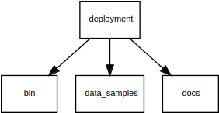igure 16: The structure of the Windows (installer) deployment folder.

Automated building
This is the recommended procedure to build WorkflowMaker just after its source code has been downloaded from the repository. The following are the step-by-step instructions to build WorkflowMaker using the automated script.

First of all, take care of changing the version string of the software, but only if changes have made; this is not necessary when building the code just downloaded from the repository. Version changes must be reported in two files.

The first one is:

workflowmaker/libraries/WorkflowMakerLib/data_to_bin_folder/workflowmaker_version.txt

The typical version string follows the pattern x.y.z (e.g., 1.0.8). Change this value if necessary in the unique line this file contains and then save it.

The second file to change is the NSIS script controlling how the installer is built. This file is located at:

workflowmaker/installer/installer_sw_windows/WorkflowMaker.nsi

Edit the NSIS script and look for a line similar to:

!define defVersion "1.0.7"

at the beginning of the file. Change the version string accordingly and save the file. For instance, if the new version is 1.0.8, the new version string should be (in red, the changes):

!define defVersion "1.0.8"

Open a MSVC 2022 x64 terminal.

Beware that a regular Windows terminal is not enough to build WorkflowMaker. Instead, a specific MSVC 2022 terminal to build x64 applications must be used. These may be started from the Visual Studio menu (in the Windows start menu). Its precise name is “x64 Native Tools Command Prompt for VS 2022”.

Change the default directory to workflowmaker

cd workflowmaker

Run the build script:

build_all.bat

The result of the execution of the script is that the deployment folder structure has been created and populated; the installer is built as well. It is located in folder:

workflowmaker/installer/installer_sw_windows

and its name is

WorkflowMaker-x.y.z-setup.exe

where x.y.z stands for the version of the package. Thus, if for example the version string is 1.0.8, then the actual name of the installer would be:

WorkflowMaker-x.y.z-setup.exe

Building by hand
Alternatively, it is possible to build WorkflowMaker by hand, building, one by one, the several projects if is composed of. However, when building WorkflowMaker by the first time (that is, when it is downloaded from the repository) the automated build process is recommended. Later on,
when changes are made to specific components of WorkflowMaker (such as a single tool, or the library), building by hand makes much more sense.

The general process to build a single library or a tool is as follows:

- Open Qt Creator.
- Select the .pro file for the desired target (the library or any of the tools).
- Configure the project (selecting the Qt 6 installed in your computer and the target output).
- Build.

Building manually any of the components, either library or tools, will also copy the corresponding files to the deployment folder structure (see section 4.2.3) as it is done by the automated process.

It is worth noting that changing the library implies rebuilding all the tools to guarantee that these changes are conveniently propagated. In general, when building manually, libraries must be built first, then the tools.

Building the installer (when building manually)
When changes are made to individual components of WorkflowMaker and these changes are built using the manual procedure (section 4.2.5) the installer is not rebuilt automatically. In these cases, it is necessary to re-build it by hand.

Before rebuilding the installer by hand, make sure that all the tools that have been changed and therefore included in the new version of the installer have been built.

Changing the version string, but only if changes have made; this is not necessary when building the code just downloaded from the repository. Version changes must be reported in the file:

workflowmaker/libraries/WorkflowMakerLib/data_to_bin_folder/workflowmaker_version.txt

The typical version string follows the pattern x.y.z (e.g., 1.0.8). Change this value if necessary in the unique line this file contains and then save it.

Open the installer script.

This is file workflowmaker/installer/installer_sw/WorkflowMaker.nsi.

Open this file using the HM NIS EDIT editor (see section 2) only, since it is integrated with the NSIS installer system and only from here it will be possible to build the installer.

Change the version of the installer, but again, only if changes have been made.

Do this only when the version of the installer must reflect a change in the version of the software. If the installer is just being regenerated, it is not necessary to change the installer’s version.

To change the version, look for the following line close to the beginning of WorkflowMaker.nsi:

!define defVersion "1.0.7"

(the actual version number may be different) and change the version string as needed. For instance:

!define defVersion "1.0.8"

Save the installer script. Only if it has been modified by the previous step.

Build the installer.

To do it, click on the build button in the editor’s toolbar (see Figure 17).

Close HM NIS Edit.

The installer is created in the folder

workflowmaker/installer/installer_sw

and it is named

WorkflowMaker-x.y.z-setup.exe

where x.y.z corresponds to the version string indicated in the installer script (see previous steps). Thus, if such version string is, for instance, 1.0.8, the name of the installer woud be:

WorkflowMaker-1.0.8-setup.exe

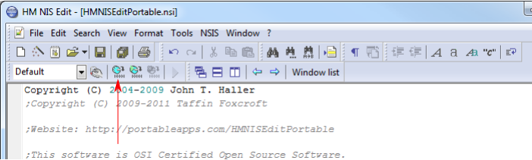Figure 17: Building the windows installer using HM NIS Edit.

Running this installer will install WorkflowMaker on the target Windows computer. Note that it includes not only the applications but also the documentation and samples.

The API documentation
When the source code for WorkflowMaker is downloaded from the repository, no documentation for the APIs of the libraries or the classes in the tools is included. The reason is simple: this documentation is generated automatically each time WorkflowMaker is rebuilt completely by means of the automated script (sections 4.1.3 and 4.2.4) or any of its components (library, tools) are built manually (sections 4.1.4 and 4.2.5). In this way, and assuming that the documentation is properly updated in the source code when changes are made, the API documentation will always be up to date. This task is assumed by the postbuild.bat / postbuild.sh and .dox files included with each library or tool.

The documentation is created in a new folder named doc_html, which is located in the respective directories of each of the WorkflowMaker libraries or tools. As the name of the folder suggests, the documentation is created in HTML format; the main page of the documentation (for each library of tool) is the file index.html.

Figure 18 depicts, highlighted in red, the location of this folder for the ToolkitEditor tool.

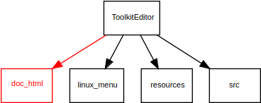Figure 18: The doc_html folder for the ToolkitEditor tool including its API documentation.

Consequently, to open the API documentation for each of the components making WorkflowMaker, the files to check are, respectively:

- Libraries
  - WorkflowMakerLib
workflowmaker/libraries/WorkflowMakerLib/doc_html/index.html
  - rapidxml
There is no documentation folder for this library. It is an open source project that may be found here:
https://rapidxml.sourceforge.net/
The documentation for this library may be checked here:
https://rapidxml.sourceforge.net/manual.html
- Tools
  - ToolkitEditor
workflowmaker/tools/ToolkitEditor/doc_html/index.html
  - WorkflowEditor
workflowmaker/tools/WorkflowEditor/doc_html/index.html
  - WorkflowLauncher
/home/janavaro/Desarrollo/WorkflowMaker/tools/WorkflowLauncher/doc_html/index.html

As stated above, these files will not be available until WorkflowMaker is built at least once.

Figure 19 shows the documentation of one of the classes included in the ToolkitEditor tool.

Figure 19: An example of the API documentation in HTML format.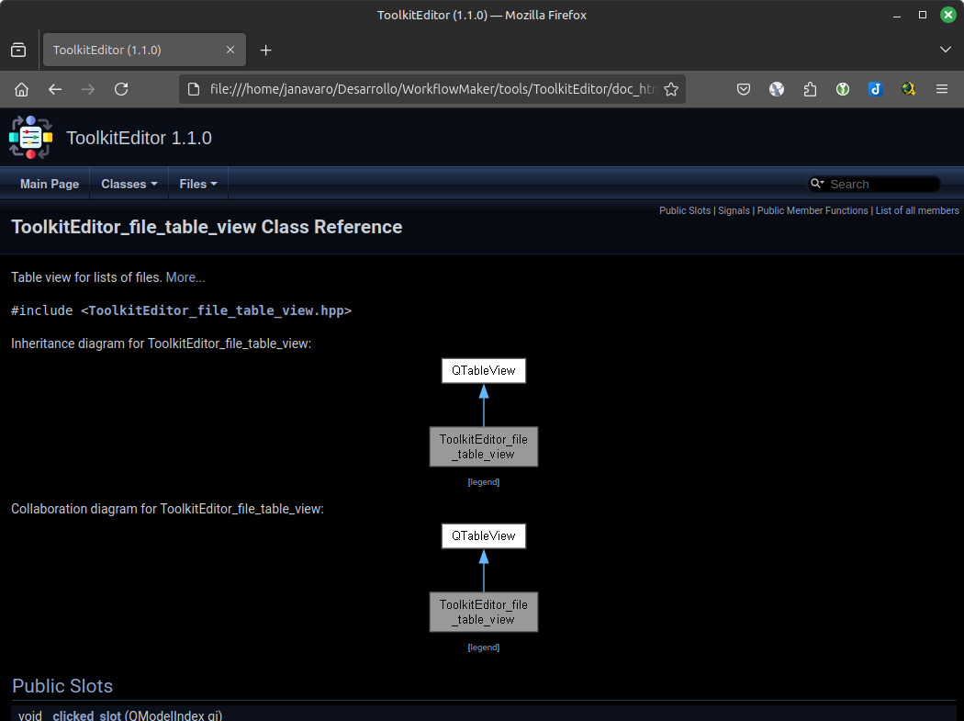

Open Source licenses
WorkflowMaker relies on several open source libraries and it is also distributed as open source.

The rapidxml library
This application uses the rapidxml library, which is available under the Boost Software License. For more information, visit https://www.boost.org/LICENSE_1_0.txt. A copy of this license may be found in the workflowmaker/doc/licenses folder.

The Qt 6 framework
This application uses the Qt 6 framework, which is available under the LGPL v3 license. For more information, visit https://www.qt.io/licensing and https://www.gnu.org/licenses/lgpl-3.0.html. A copy of the LGPL v3 license may be found in the workflowmaker/doc/licenses folder.

Images
All the icons used by the applications have been built using images downloaded from freepik.com. These have been the images used:

adaptation_5266710.png
filter_3126489.png
gear_937458.png
pencil_10183063.png
rocket_8661082.png

WorkflowMaker
This project is licensed under the MIT License. See the LICENSE file in the root folder of the source code distribution for details.

